Linux Programming: Assignment-3

- Distinguish between man and whatis commands? Justify with proper example.
- The man command displays the full manual page of a command, including description, syntax, options, usage, and related information.
    - e.g.) man ls //This shows the complete manual page of the ls command.

- The whatis command gives a one-line short description of a command taken from the manual page.
  - e.g.) whatis ls //output : ls (1) - list directory contents

- Thus, man provides detailed documentation, while whatis gives a quick overview of what the command does.

- Use the tee command to save the output of ls -l into a file while also displaying it.
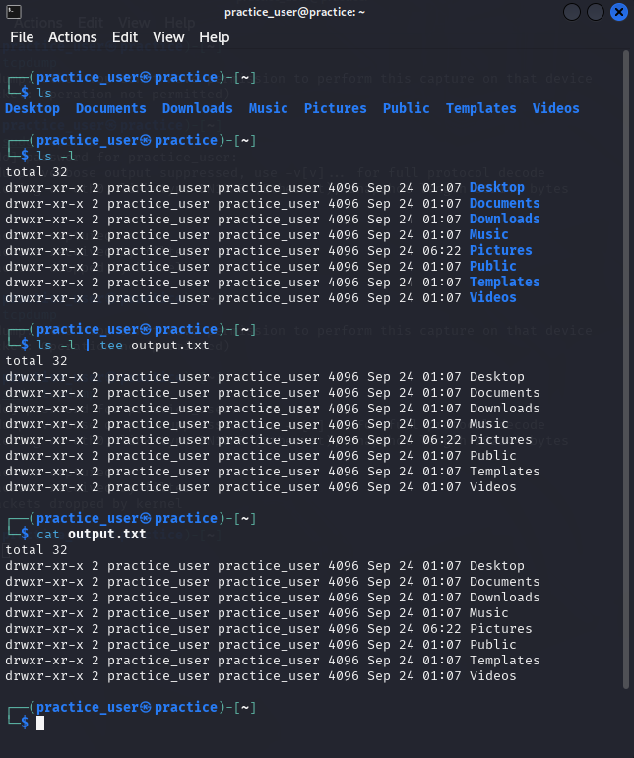
- Explain with an example how the tee command can be used in logging.
- The tee command can be used in logging to record the output of a program or script into a log file while still displaying it on the terminal for real-time monitoring.

- E.g.) ping -c 4 google.com | tee ping.log

This command strictly ping 4 packets of data to this target domain and then the results will be piped and saved to “ping.log” for refrence .

- List the steps involved in installing Ubuntu 25.04 LTS on Oracle VirtualBox.
- Download Oracle VirtualBox for your host OS and install it.
- (Optional but recommended) Download and install the matching VirtualBox Extension Pack for USB/RDP/features.
- Download the Ubuntu 25.04 LTS ISO from the official Ubuntu site and save it to a known folder.
- Open VirtualBox and click New to create a VM. Enter a name (e.g., Ubuntu-25.04) and set Type to Linux, Version to Ubuntu (64-bit). Click Next.
- Assign RAM. Choose 4096 MB (4 GB) or at least 2048 MB if your host is limited. Click Next.
- Create a virtual hard disk: select Create a virtual hard disk now → VDI → Dynamically allocated → size 25 GB (recommended 40–50 GB for comfortable use). Click Create.
- Select the new VM and open Settings → System → Motherboard: ensure Enable EFI is off (unless you specifically need EFI). Set boot order so Optical is before Hard Disk.
- In Settings → System → Processor, assign 2 CPUs if available.
- In Settings → Display, set Video Memory to 128 MB and enable 3D Acceleration (if host supports it).
- In Settings → Storage, click the empty optical drive, choose Choose a disk file, and attach the Ubuntu 25.04 ISO you downloaded.
- In Settings → Network, keep Attached to: NAT (default) for internet. If you need the VM visible on LAN, use Bridged Adapter. Save settings.
- Start the VM (click Start). The VM will boot from the ISO and show the Ubuntu installer menu.
- Choose Install Ubuntu (or Try then Install). Select keyboard layout. Choose Normal installation, and check Download updates while installing (if you have internet). Optionally check Install third-party software for drivers/codecs.
- Disk setup inside installer: choose Erase disk and install Ubuntu (this affects only the virtual disk). Confirm and continue.
- Set time zone, create your user (username + password), and follow installer prompts. Wait for files to copy and installation to complete.
- When prompted, Restart Now. If VirtualBox still has the ISO mounted, go to Devices → Optical Drives and uncheck/eject the ISO so the VM boots from the virtual hard disk.
- Log in to your new Ubuntu VM with the username/password you created.

- During Ubuntu OS installation, you face a Kernel Panic Error. How would you troubleshoot it?
- First, I would check if the Ubuntu ISO file is not corrupted by comparing its checksum with the one given on the Ubuntu website.
- If the ISO is fine, I would recreate the bootable USB/DVD because sometimes the writing process fails.
- In VirtualBox or BIOS, I would enable virtualization settings and also try giving the VM more RAM and processors.
- At the GRUB screen, I would try to add boot options like nomodeset to avoid graphics or driver-related issues.
- If the problem continues, I would try installing a different version of Ubuntu, like the previous LTS, to see if it works.
- Finally, I would also update VirtualBox or BIOS because older versions sometimes cause kernel panic.

- Write the command to display the system’s hostname? How to change hostname using sysctl command?
- To display the system’s hostname use : hostname
- to change the hostname using sysctl :
    - sudo nano /etc/hostname
    - Then replace the old hostname with the new one and save the file
    - Then run : “sudo systemctl restart systemd-logind” this will restart the systemd-logind service that manages user logins,sessions, and related stuff.

- Which command is used to show the calendar of the year 1984 with August month?
- cal 8 1984

- Write a command to display system uptime and logged-in users together.
- W

- Use the find command to list all “.c” files in /home/user.
- find /home/user -name "*.c"

- How do you change file permissions to allow only the owner to read and write?
- chmod 600 filename.txt

